2DES

<https://chatgpt.com/c/690cdb01-8f54-832c-b03c-7e31b58a86c5>

injection types

<https://chatgpt.com/c/690c9c13-1908-8322-8294-b28bae53d5b6>

SQL:

<https://chatgpt.com/c/68dcc7af-9c98-8332-b602-a6f52f0c45aa>

AES

<https://chatgpt.com/c/68fc9af1-0df4-8321-b84d-21801b94a6ee>

buffer

<https://chatgpt.com/c/68d6738a-72c4-8324-bd4a-64ecf8a5e428>

Sem course

<https://chatgpt.com/c/689c634b-2064-8329-b540-518c0a58dd72>

Ass help

<https://chatgpt.com/c/68c7a0be-f2e4-8320-b42c-05a74206e06c>

MID1

<https://chatgpt.com/c/68d1355e-2dfc-832a-bc3e-1951f8215d6b>

Dear All,

The topics are included in the Final exam of Information Security:

Introduction to Security:

The CIA Triad: Confidentiality Integrity and Availability

Challenges of Securing Information

Security Models

Principles of Design and Defense Standards & Frameworks

The Threat Landscape:

Terminology

Employee and Ex-Employee Threats Hackers and Attacks

The Criminal Era Competitor Threats

Cyberwar and Cyberterrorism Malware and Social engineering

Software Security:

Introduction to Memory Buffers

Memory Layout in Programs

Understanding Buffer Overflow

Vulnerabilities

Exploiting Buffer Overflow: Techniques

and Methods

Buffer Overflow Mitigation Strategies

Database Security:

SQL injection Attack

SQL injection & countermeasures

Web Security

HTTP sessions & cookies

Session Hijacking & mitigation

Cookie theft

Cross-Site Request Forgery (CSRF) & countermeasures

Same-origin policy (SOP)

Cross-site scripting (XSS) & countermeasures

Cryptography

Classic Ciphers

Computational Hardness

Symmetric key encryption, (DES, double and triple DES) (AES)

Asymmetric Encryption, (RSA)

Hash Functions, (SHA-512)

Diffie Hellman Key Exchange

Public Key Infrastructure (PKI)

Access Control and Authentication

User Authentication, Authorizations, and

Discretionary Access Control, Role-based Access Control and Attribute based Access Control

Secure Networks

DDoS attacks

Wireless Security

Firewalls

................................................................................................

Paper Pattern:

Final exam is divided into two parts: Objective and Subjective

1. Objective Portion (MCQs and short questions) will be from these Sections: Secure Networks, Database Security, Introduction to Security, Threat Landscape

2. Subjective Portion: The rest of the topics will be considered for subjective part. Anything can be expected long/short questions, numerical, diagrams/labelling etc.

So prepare well if you want to score well.

Best of Luck !!! :)

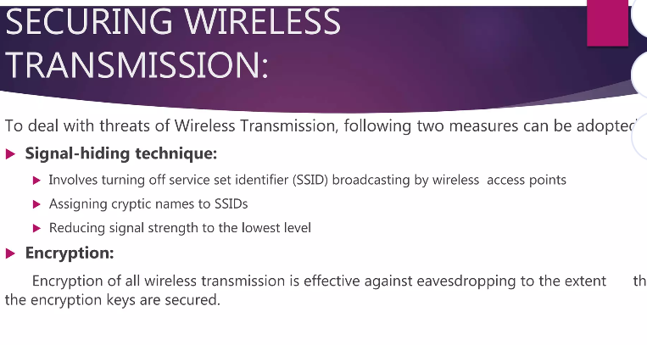

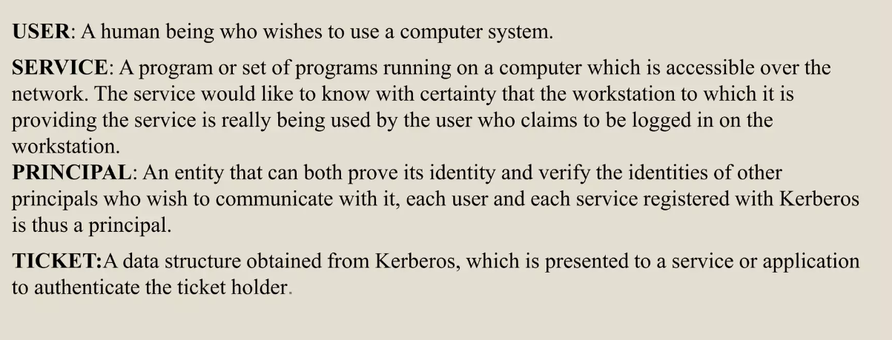

Mock Mid objective

<https://chatgpt.com/s/t_694849f391d08191b69194ee00233189>

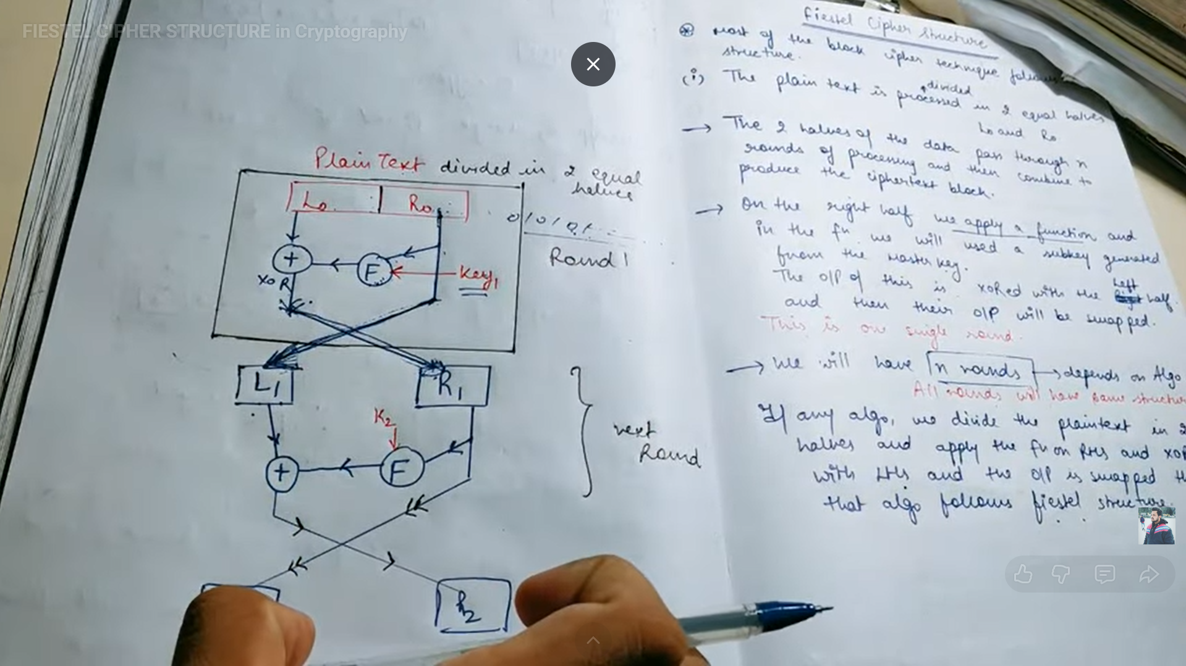

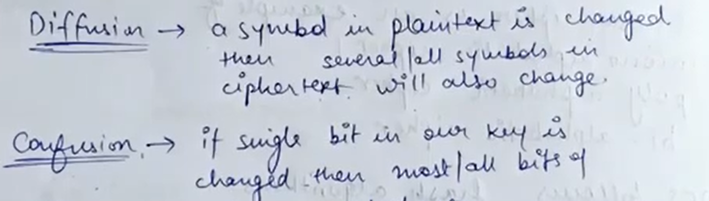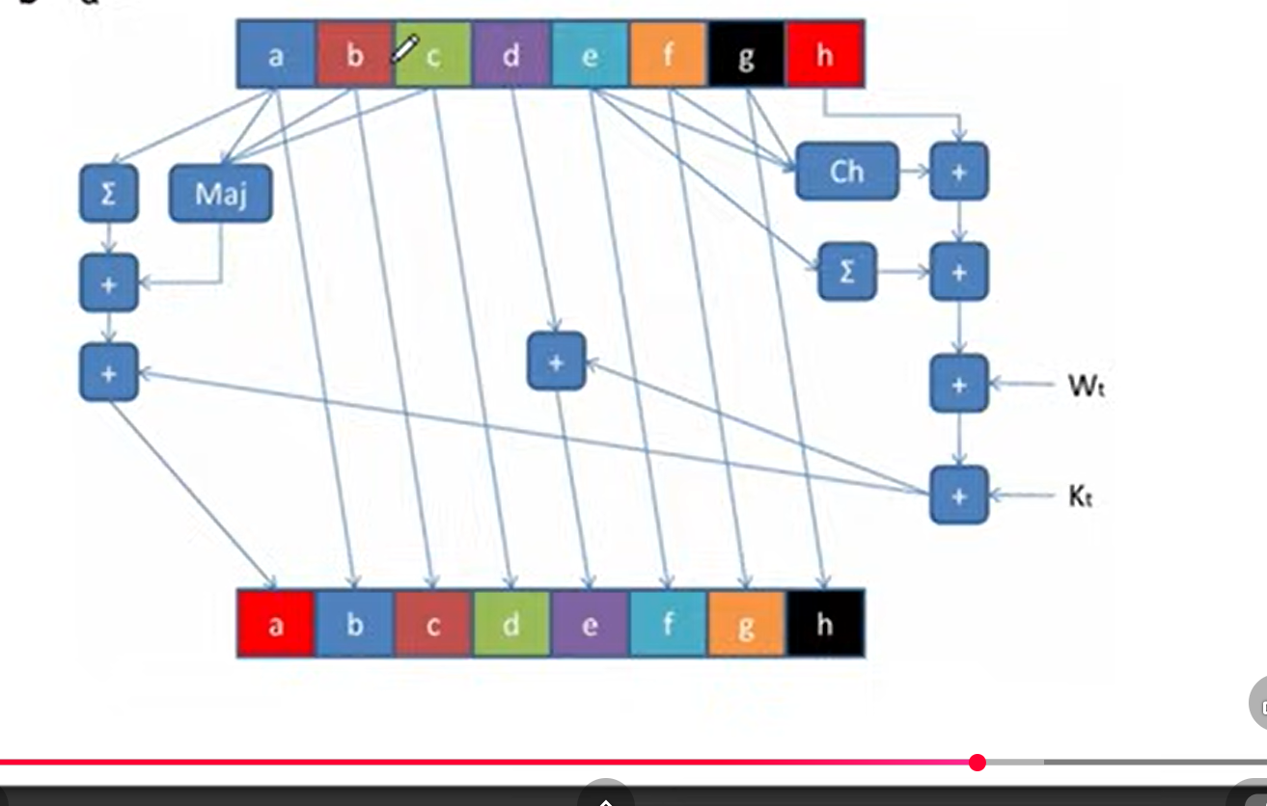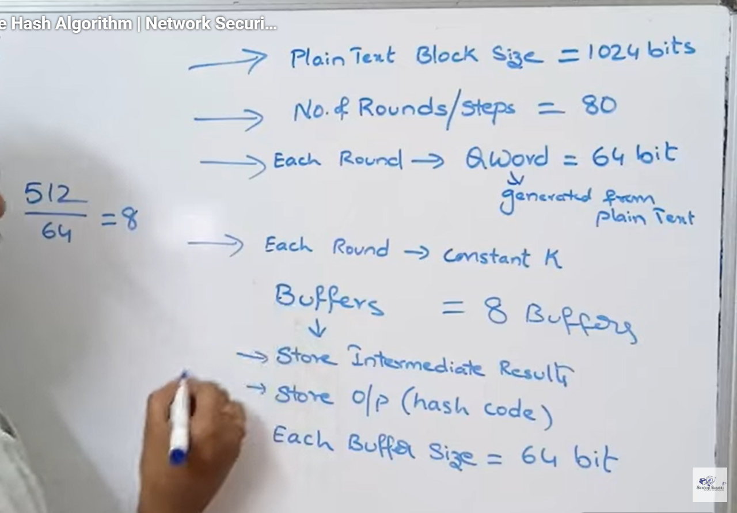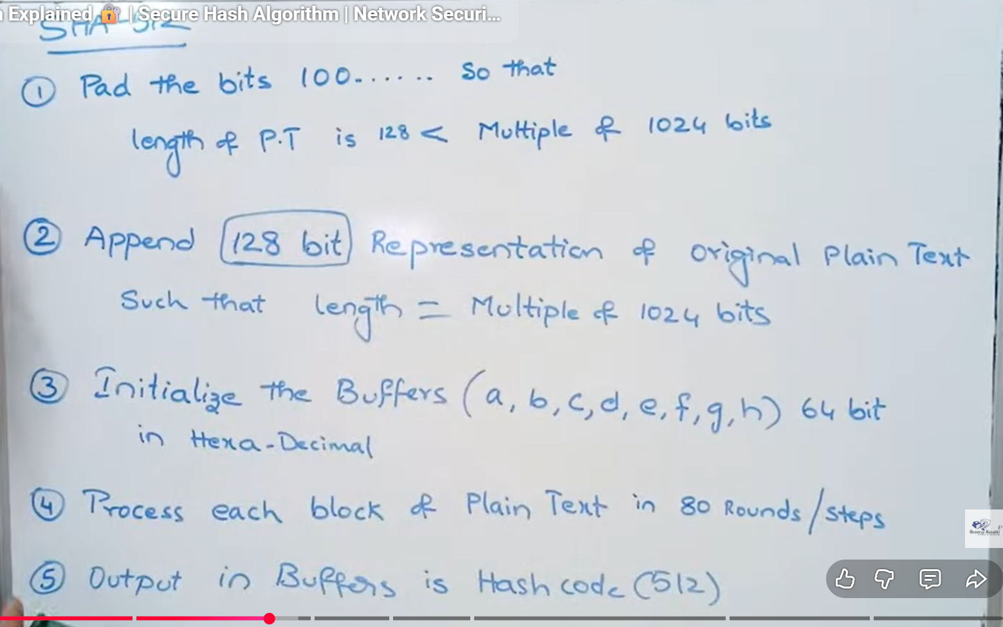

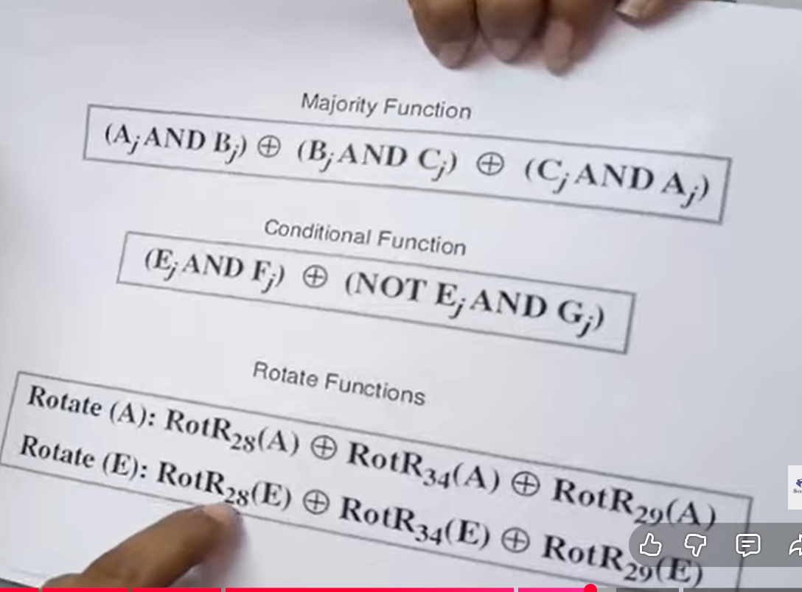

SHA FORmulas

<https://chatgpt.com/s/t_694d8f2dcb94819186de133f3b35361c>

Perfect — here is a **COMPLETE SHA CHEAT-SHEET (exam-ready)** covering **all formulas**:  
ROTR, SHR, Σ, σ, Ch, Maj, word schedule, and working variables **a–h**.  
I’ll give **SHA-512 first** (since you asked that most), then a **SHA-256 note**.

# 🔐 SHA-512 COMPLETE FORMULA CHEAT-SHEET

## 1️⃣ Basic parameters (SHA-512)

* **Block size:** 1024 bits
* **Word size:** 64 bits
* **Message schedule words:** W[0..79]
* **Working registers:** a, b, c, d, e, f, g, h
* **Rounds:** 80

## 2️⃣ Bit operations (core)

### 🔹 ROTR (Rotate Right)

[  
ROTR^n(x) = (x \gg n) ;|; (x \ll (64-n))  
]

### 🔹 SHR (Shift Right, logical)

[  
SHR^n(x) = x \gg n  
]

## 3️⃣ Small sigma functions (σ) — used in ****word creation****

[  
\boxed{  
\sigma_0(x) = ROTR^1(x) \oplus ROTR^8(x) \oplus SHR^7(x)  
}  
]

[  
\boxed{  
\sigma_1(x) = ROTR^{19}(x) \oplus ROTR^{61}(x) \oplus SHR^6(x)  
}  
]

## 4️⃣ Message schedule (Word calculation)

### 🔹 For first 16 words:

[  
W[t] = \text{message block word } t \quad (0 \le t \le 15)  
]

### 🔹 For remaining words:

[  
\boxed{  
W[t] = \sigma_1(W[t-2]) + W[t-7] + \sigma_0(W[t-15]) + W[t-16] \pmod{2^{64}}  
}  
]

## 5️⃣ Big Sigma functions (Σ) — used in ****rounds****

[  
\boxed{  
\Sigma_0(x) = ROTR^{28}(x) \oplus ROTR^{34}(x) \oplus ROTR^{39}(x)  
}  
]

[  
\boxed{  
\Sigma_1(x) = ROTR^{14}(x) \oplus ROTR^{18}(x) \oplus ROTR^{41}(x)  
}  
]

## 6️⃣ Logical functions

### 🔹 CH (Choose)

[  
\boxed{  
Ch(x,y,z) = (x \land y) \oplus (\neg x \land z)  
}  
]

👉 “Choose y if x=1, else z”

### 🔹 MAJ (Majority)

[  
\boxed{  
Maj(x,y,z) = (x \land y) \oplus (x \land z) \oplus (y \land z)  
}  
]

👉 Bit that appears **at least twice**

## 7️⃣ Round computation (core SHA logic)

For each round (t = 0..79):

### 🔹 Temporary values

[  
\boxed{  
T_1 = h + \Sigma_1(e) + Ch(e,f,g) + K[t] + W[t]  
}  
]

[  
\boxed{  
T_2 = \Sigma_0(a) + Maj(a,b,c)  
}  
]

## 8️⃣ Update working registers (a–h)

[  
h = g  
]  
[  
g = f  
]  
[  
f = e  
]  
[  
e = d + T_1  
]  
[  
d = c  
]  
[  
c = b  
]  
[  
b = a  
]  
[  
\boxed{  
a = T_1 + T_2  
}  
]

(All mod (2^{64}))

## 9️⃣ Hash value update (after 80 rounds)

[  
H_0 = H_0 + a  
]  
[  
H_1 = H_1 + b  
]  
[  
\ldots  
]  
[  
H_7 = H_7 + h  
]

Final hash =  
[  
H_0 | H_1 | H_2 | H_3 | H_4 | H_5 | H_6 | H_7  
]

# 🔁 SHA-256 DIFFERENCES (VERY SHORT)

| **Feature** | **SHA-256** |
| --- | --- |
| Word size | 32 bits |
| Words | 64 |
| σ₀ | ROTR⁷ ⊕ ROTR¹⁸ ⊕ SHR³ |
| σ₁ | ROTR¹⁷ ⊕ ROTR¹⁹ ⊕ SHR¹⁰ |
| Σ₀ | ROTR² ⊕ ROTR¹³ ⊕ ROTR²² |
| Σ₁ | ROTR⁶ ⊕ ROTR¹¹ ⊕ ROTR²⁵ |
| Modulo | (2^{32}) |

## 🧠 ONE-LINE MEMORY TRICK

* **σ (small)** → message schedule
* **Σ (big)** → compression rounds
* **CH** → conditional choice
* **MAJ** → majority vote
* **W[t]** → expanded message
* **a–h** → rolling state

If you want, next I can:

* Compress this into **1-page exam sheet**
* Show **one full round with numbers**
* Or give **mnemonics to memorize Σ and σ values**

Just tell me 👍

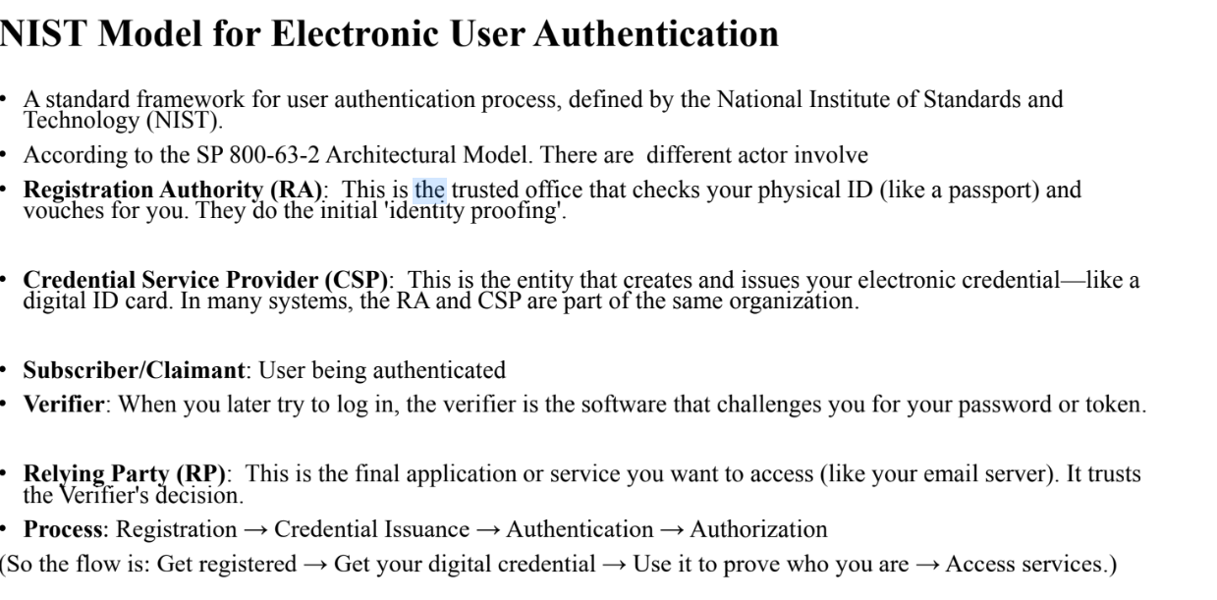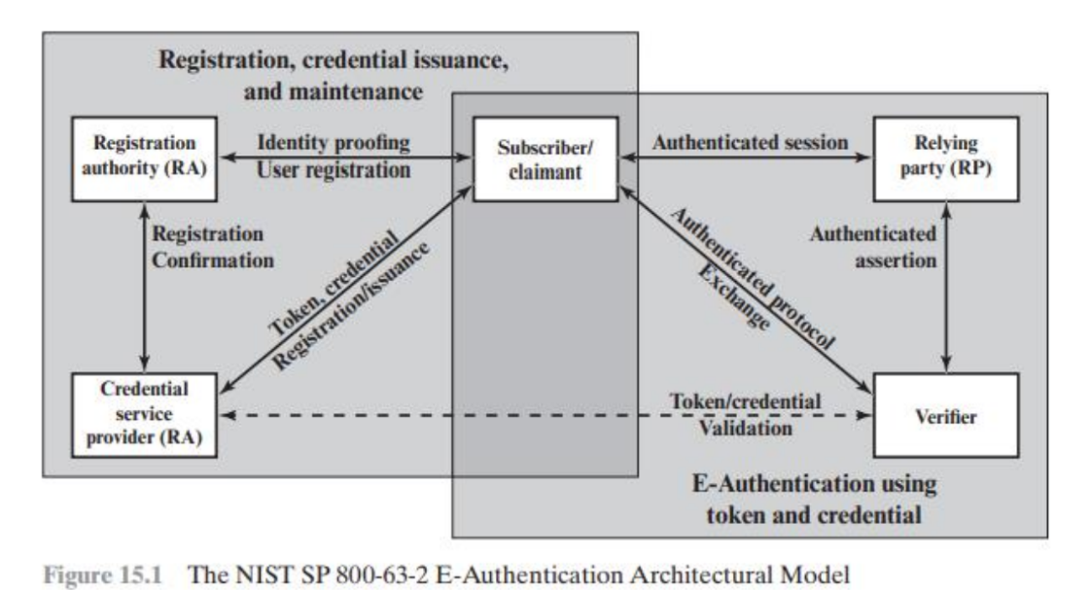

**7️⃣ Rotor Machine Ciphers (Electro-Mechanical Era)**

**🔸 Method Overview**

* **Type:** *Polyalphabetic substitution cipher* implemented **mechanically**.
* Introduced early 1900s — used extensively in WWII (e.g., **German Enigma machine**).
* Each **rotor (wheel)** performs one substitution alphabet.
* After encrypting one letter, rotors **rotate** (like an odometer), changing the mapping for the next letter.
* This provides an **ever-changing cipher alphabet**.

**🔸 Encryption Process (Conceptual)**

1. **Rotors** — Each rotor contains a wiring pattern that permutes 26 letters (like a substitution cipher).
2. **Keyboard input** — The user types a plaintext letter (e.g., A).
3. The electrical current passes through:
   * Rotor 1 → Rotor 2 → Rotor 3 → Reflector → back through the rotors in reverse order.
4. Each pass substitutes the letter multiple times, producing ciphertext output (e.g., G).
5. After each letter, **rotor 1 rotates one step**, occasionally causing the next rotor to rotate (like a clock gear).

Thus, **each letter is encrypted with a different substitution alphabet**, depending on rotor positions.

**🔸 Example (Simplified)**

Assume 3 rotors.

* Rotor 1 shifts by +1 each letter
* Rotor 2 shifts by +1 every 26 letters
* Rotor 3 shifts by +1 every 26×26 letters

So “AAAA” would encrypt as different letters (because shift changes after each letter).

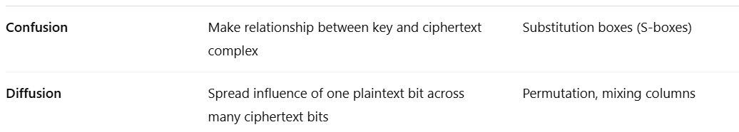s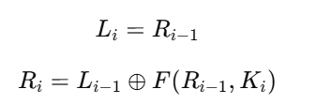

A Prepared Statement (or Parameterized Query) is a precompiled SQL statement that allows you to safely insert user-supplied data by binding it as parameters — not as part of the SQL string. Normally, when developers use **string concatenation**, SQL Injection happens.

❌ **Insecure Example:**

user = input("Enter username: ")

query = "SELECT * FROM users WHERE name = '" + user + "';"

If user types:  
' OR '1'='1  
→ the final SQL becomes:

SELECT * FROM users WHERE name = '' OR '1'='1';

This returns **all rows** — SQL Injection.

✅ **Secure (using Prepared Statement):**

cursor.execute("SELECT * FROM users WHERE name = %s", (user,))

Now the database treats user as **data**, not SQL code.

**🔹 3. How they work internally**

1. SQL query is first **compiled** with placeholders (?, :name, or %s).
2. Then values are **bound** to these placeholders.
3. The DBMS ensures these values **cannot alter** the SQL structure.

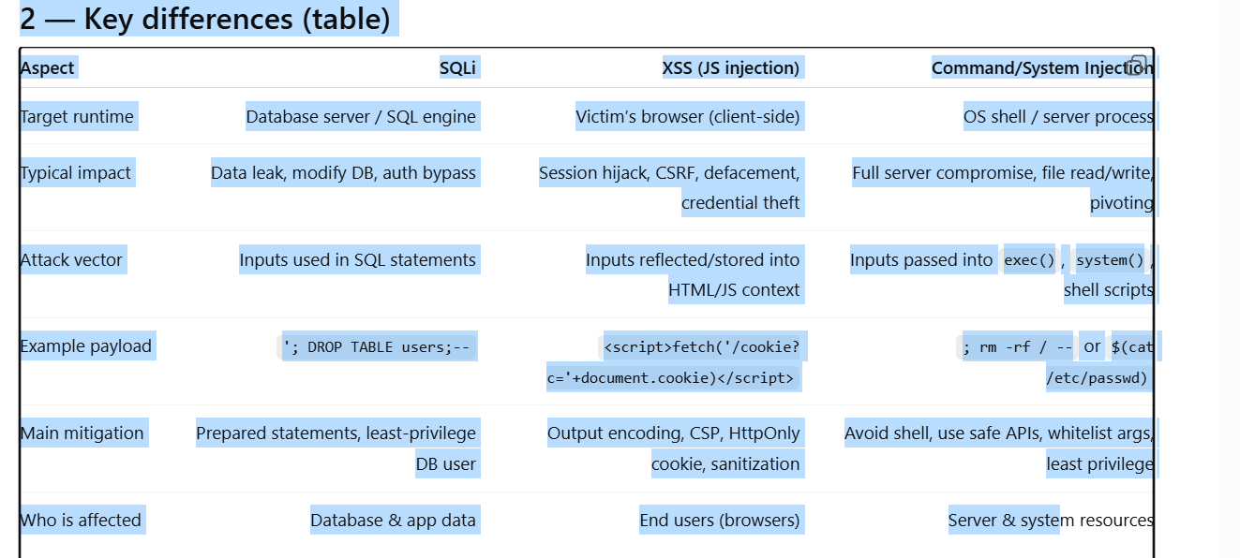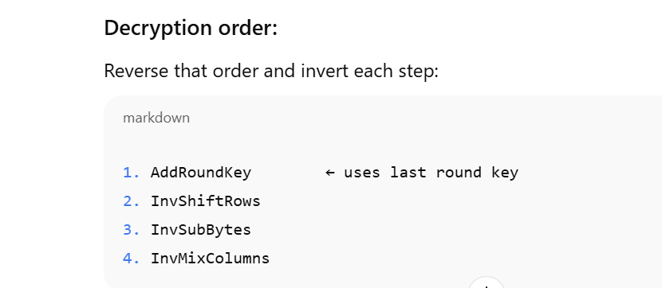So, when decrypting:

* You **start** by applying **K10** (the last encryption key) to the ciphertext.
* Then inside **Round 1 of decryption**, you later apply **K9** before doing InvMixColumns.

Thus — both **K10** and **K9** appear during “decryption round 1,”  
but each belongs to a different reversed encryption step.

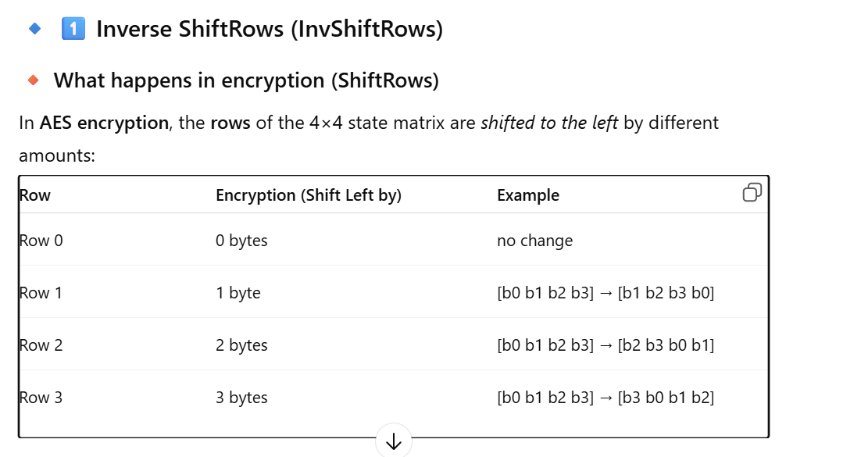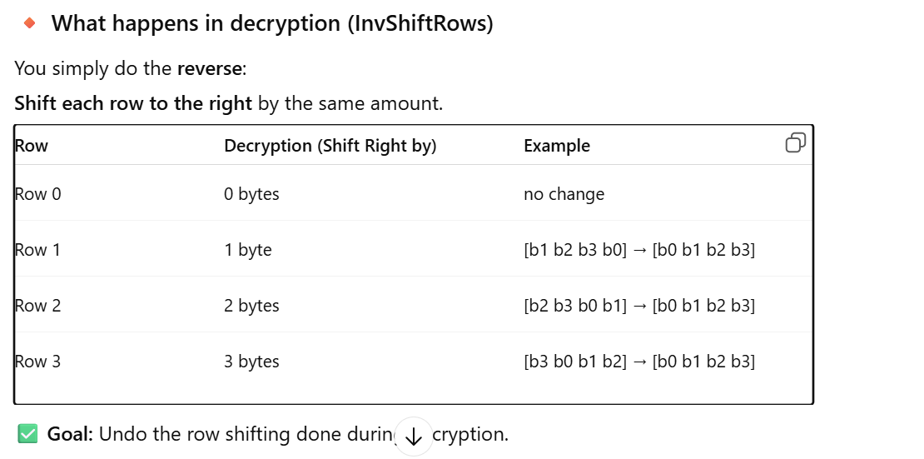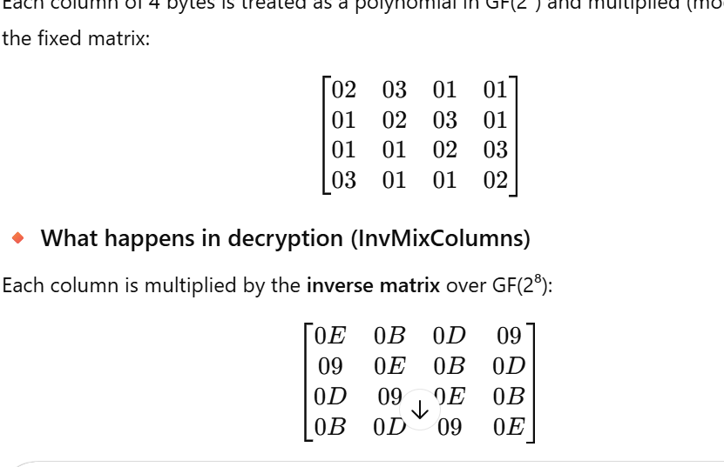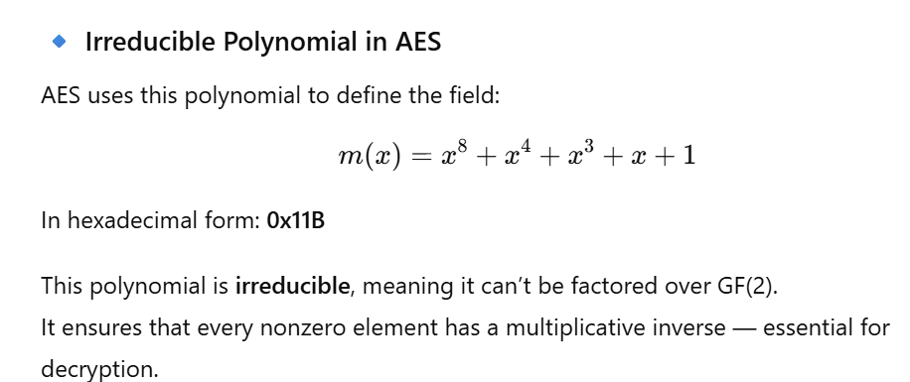If AES didn’t use Rcon, the key expansion would produce predictable patterns — like repeating keys — which weakens security.  
Rcon ensures that every round key is mathematically different, even if parts of the main key repeat. 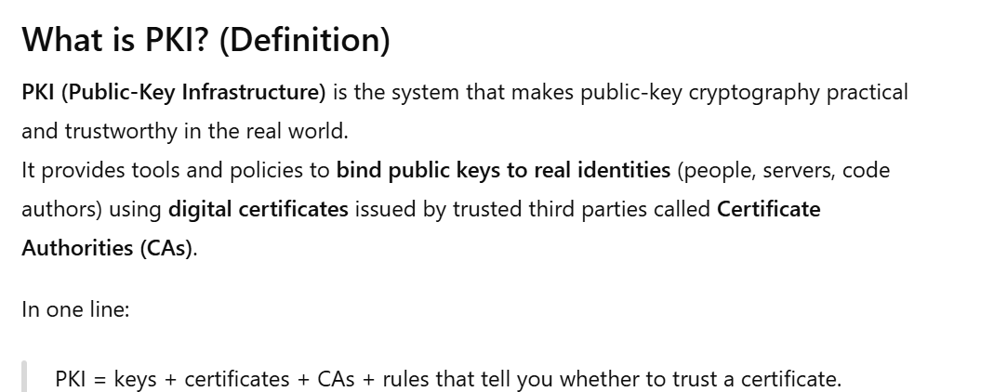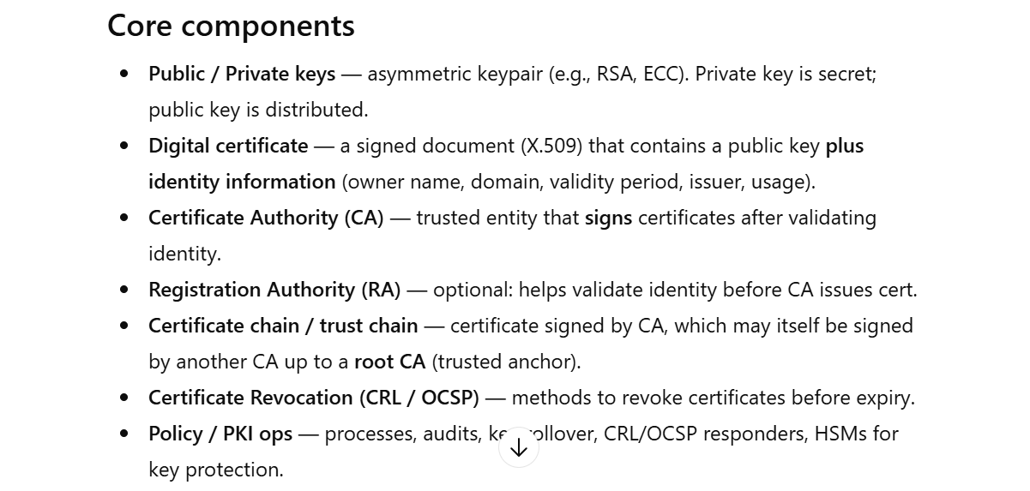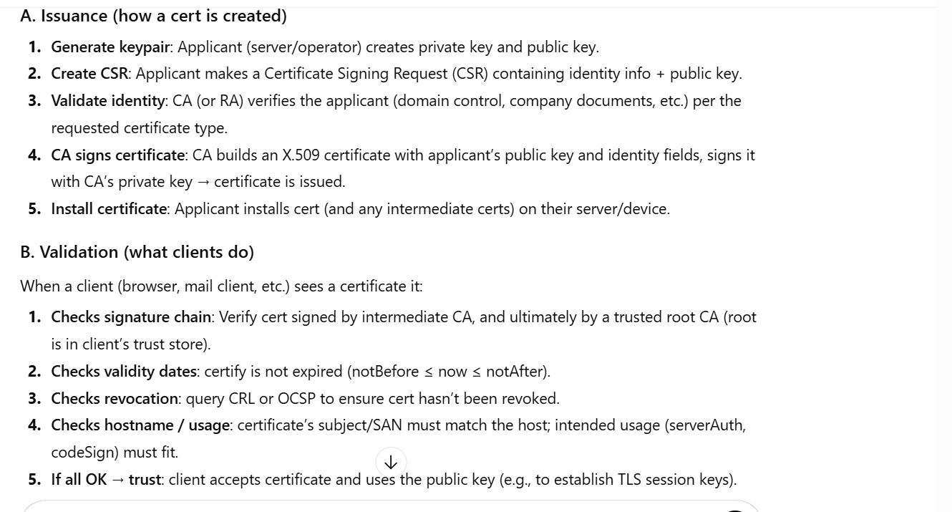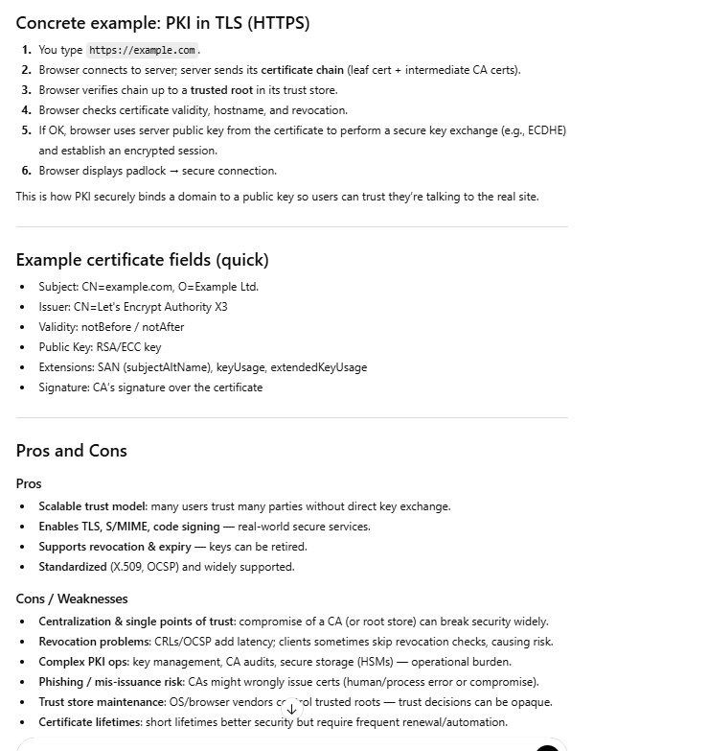

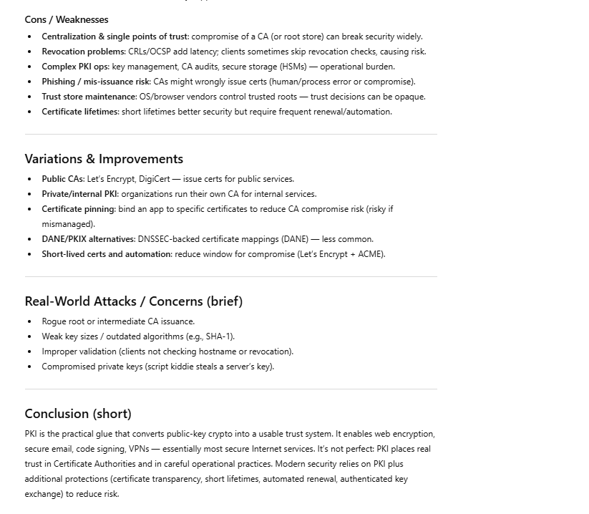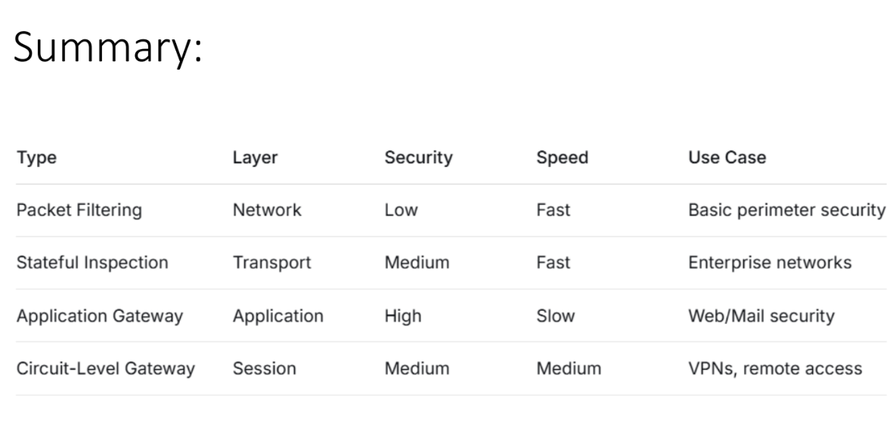

| **Concept** | **Description** |
| --- | --- |
| **Rcon** | Round Constant used in key expansion |

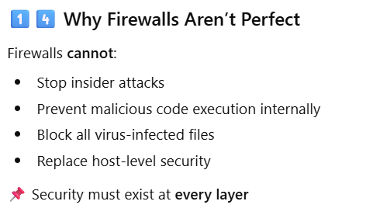• defense.

• **What is the difference between stateless and stateful firewalls?**  
Stateless firewalls filter packets individually based on IP, port, and protocol, ignoring connection context. Stateful firewalls track the state of active connections, allowing only packets that belong to established sessions.

• **Explain the concept of implicit deny in firewall rule sets.**  
Any traffic not explicitly permitted by firewall rules is automatically denied, enforcing least privilege.

• **What are the main limitations of packet-filtering firewalls?**  
Cannot track sessions, vulnerable to IP spoofing and fragmented packets, limited to network/transport layer checks.

**Explain a SYN flood attack in brief.**  
SYN flood exploits TCP handshake by sending numerous SYN requests without completing the handshake, exhausting server resources. • **List two common mitigation techniques for DDoS attacks.**  
Rate limiting incoming traffic and deploying traffic filtering through firewalls or IDS/IPS.

• **Explain how amplification attacks increase DDoS impact.**  
Attackers exploit services that send larger responses than requests, multiplying traffic volume toward the victim.

• **Why can firewalls alone not stop DDoS attacks?**  
Firewalls cannot handle extremely high traffic volumes from multiple sources and cannot differentiate between legitimate and attack traffic at scale.

The idea of the damage is that we overflow the buffer and replace our data until the data replace the

return address.

We place the address of our code (A) with return address.

So if we can run our code and we can do damage

Here is the **same explanation in very easy words**, clean and exam‑ready 👇

**Why does a program crash after a buffer overflow? (Easy words)**

* A buffer overflow **overwrites the return address** with random or attacker‑supplied data.
* When the function finishes, the program tries to **jump to this wrong address**.
* Because the address is wrong or unsafe, the program crashes.

**What can go wrong (simple scenarios)**

**1️⃣ Jump to an address that does not exist**

* Address is **not mapped in memory**
* OS detects invalid access
* **Process is killed**

**2️⃣ Jump to garbage / invalid instructions**

* Address exists, but data there is **not real code**
* CPU cannot execute it
* **Program crashes**

**3️⃣ Jump to protected memory (kernel area)**

* Address belongs to **OS kernel**
* User program is **not allowed** there
* CPU blocks it → **crash**

**4️⃣ No valid return address**

* Return pointer is corrupted or missing
* Program doesn’t know where to continue
* **Crash occurs**

**One‑line exam answer**

A buffer overflow crashes a program because it overwrites the return address, causing execution to jump to an invalid or unauthorized memory location.

If you want, I can also shorten this to a **5‑mark answer** or draw a **tiny stack diagram**.

## /bin/sh and /bin/zsh (shells)

* /bin/sh → basic shell
* /bin/zsh → advanced shell (Z shell)

If you run a shell **with root privileges**, you get:

# /bin/sh

# /bin/zsh

That means:

* You now have a **root shell**
* Full system control

## /bin/sh and /bin/zsh (shells)

* /bin/sh → basic shell
* /bin/zsh → advanced shell (Z shell)

If you run a shell **with root privileges**, you get:

# /bin/sh

# /bin/zsh

That means:

* You now have a **root shell**
* Full system control

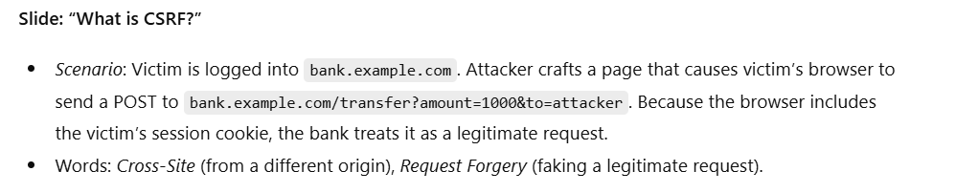**Slide: “Why CSRF works”**

* Browsers automatically attach cookies, HTTP basic auth, and sometimes client TLS certs to requests for the origin.
* Server-side absence of a per-request binding (token/nonce) that proves the user intentionally initiated the action.

**Slide: “Same-origin policy vs CSRF”**

* Same-origin policy (SOP) restricts reading cross-origin responses in browsers, but **does not** prevent sending cross-origin requests. That means an attacker can cause victim’s browser to send a request (POST/GET) but cannot read the response (without CORS), yet reading the response is not needed for many CSRF payloads.

**Slide: “Typical CSRF attack flow (step by step)”**

1. Victim logs in to victim-site and gets session cookie.
2. Victim visits attacker page (malicious).
3. Attacker page submits a form or triggers an image/JS fetch to perform state-changing action on victim-site.
4. Browser attaches victim’s cookie → server accepts the request as authenticated.
5. Attacker achieves action (e.g., transfer money).

Explain methods attackers use: hidden auto-submitting forms, <img> GET requests, JavaScript fetch() (subject to CORS/read limitations but can still send), or CSRF via forged POST via dynamic form + form.submit().

## 6. ****How to Defend****

* **Against Passive:**
  + Strong encryption (SSL/TLS, VPNs)
  + Secure key exchange
  + Avoid metadata leaks
* **Against Active:**
  + Digital signatures & hashing
  + Authentication (2FA, biometrics)
  + Intrusion Detection Systems (IDS)
  + Redundancy for availability

**2. Types of Malware**

**A) Concealment-based Malware**

1. **Trojan Horses**
   * Pretend to be legitimate programs (e.g., "Free Antivirus" but installs a virus).
   * Once installed → attackers can **delete/modify data, spy, add to botnets**.
2. **Backdoors (Trapdoors)**
   * Secret entry point into a system.
   * Example: Developer intentionally leaves a hidden password bypass in software.
3. **Logic Bombs**
   * Hidden malicious code inside legitimate software.
   * Activates under certain conditions (date/time/file absence).
   * Example: Employee plants a logic bomb to wipe files if he is fired.
4. **Rootkits**
   * Special malware that **hides itself** and gives attackers **admin control**.
   * Delivered through phishing, software vulnerabilities, or bundled with pirated files.

**B) Infection-based Malware**

1. **Viruses**
   * Self-replicating code that infects files/programs.
   * Needs a host (like .exe or .doc).
   * Spread via email attachments, file sharing, websites.
   * Example: "ILOVEYOU" virus spread via infected email attachments (2000).
2. **Worms**
   * Standalone programs that self-replicate without needing a host.
   * Spread through vulnerabilities or phishing.
   * Impact: **Consume bandwidth, delete files, install backdoors**.
   * Example: "Morris Worm" (1988) caused early Internet shutdowns.

**C) Malware for Stealing Information**

1. **Spyware**
   * Secretly records activities (browsing, keystrokes, data).
   * May redirect browsing or display ads.
2. **Keyloggers**
   * Record keystrokes to steal usernames, passwords, credit card details.
   * Types:
     + **Hardware** (plugged between keyboard and PC, invisible to antivirus).
     + **Software** (installed remotely, logs keystrokes and sends to attacker).

**D) Malware for Profit**

1. **Ransomware**
   * Locks files and demands payment to restore access.
   * Example: **WannaCry (2017)** → 200k+ computers infected in 150 countries.
   * Countermeasures: Updates, antivirus, backups, avoiding suspicious attachments.
2. **Bots & Botnets**
   * Bot = infected machine controlled remotely.
   * Botnet = collection of bots (zombies) → used for **DDoS, spam, ransomware**.
   * Example: Mirai Botnet attack on IoT devices (2016).
3. **Adware & Scams**
   * Pop-ups, ads, or scam messages.
   * At best = annoying; at worst = entry point for spyware or malware.

**3. Malware Detection**

Ways to recognize infection:

* Computer slow, crashes, BSOD (blue screen).
* Pop-ups and unwanted toolbars.
* Files altered/deleted automatically.
* Emails sent without your action.

**Detection Methods**

1. **Signature Detection**
   * Based on known malware "signatures".
   * Weakness: cannot detect new/unknown malware.
2. **Change Detection**
   * Uses hash functions to check for unexpected file changes.
3. **Anomaly Detection**
   * Defines "normal" system behavior and detects deviations.
   * Example: IDS (Intrusion Detection Systems).

👉 **No single method is perfect; usually combined.**

**4. Malware Analysis**

**Purpose:** Dissect malware to understand how it works & defend against it.

* **Goals:**
  + Know what happened during attack.
  + Identify all infected machines/files.
  + Create signatures for IDS.
  + Contain and measure damage.
  + Support **incident response** & **root cause analysis**.

**5. Malware Classification**

* **Definition:** Assigning malware to a specific *family* based on shared properties.

**Types of Signatures**

* **Static Signatures**
  + Based on byte-code sequences, binary instructions, or imported DLLs.
* **Dynamic Signatures**
  + Based on malware *behavior* → file activity, commands, network traffic.

👉 Helps security teams correlate data across thousands of threats.

**6. Malware Attack Flow**

1. Infection via phishing, download, vulnerability.
2. Malware installs itself (hidden in files, processes, or memory).
3. Attacker gains control or steals info.
4. Malware spreads, replicates, or executes payload (deletes, encrypts, steals).

b) Worms can self-replicate without user interaction, viruses need a host**What is the main difference between spyware and adware?**  
👉 Spyware = secretly collects sensitive info; Adware = primarily delivers ads, but may also carry spyware.

**Q2.** In a stack frame, which of the following is typically located *just above* the local buffer?  
a) Saved base pointer (EBP)  
b) Text segment  
c) Heap pointer  
d) Data segment

✅ **Answer:** a) Saved base pointer (EBP)

# 🧱 Heap Spraying (high level)

**What it is (short):**  
A technique (common in browser exploits) where an attacker fills (sprays) large areas of heap memory with many copies of attacker-controlled data so that a later memory-corruption bug (use-after-free, out-of-bounds read/write) will more likely land on attacker-controlled content and execute it.

**Defenses & mitigations (what to study for exam):**

* **ASLR** — randomizes heap locations so sprayed objects aren’t predictably placed.
* **Heap hardening / allocator changes** — fragmentation and guard regions reduce contiguous large allocations.
* **DEP / W^X** — prevent execution of heap memory even if filled with payload.
* **Browser sandboxing, JIT hardening, and Content Security Policy (CSP)** — reduce attack surface and capability to execute sprayed data.
* **Runtime monitoring / anomaly detection** — detect abnormal mass allocations or suspicious patterns.

**Quick memory tip:** “Spray the heap with many copies so a crash lands on one.”

## ****Stack Canaries**** 🐤

* A stack canary is a secret random value placed between a buffer and the return address.
* If an attacker overwrites the buffer and also changes the canary, the program detects it and stops execution.

[ buffer ] [ CANARY_VALUE ] [ saved return address ]

## . ****ASLR (Address Space Layout Randomization)**** 🎲

* Randomizes memory addresses each time a program runs (stack, heap, libraries).
* Makes it hard for attackers to guess where shellcode or libc functions are.

**Example:**

* Without ASLR:  
  system() is always at address 0x7ffff7e12345.
* With ASLR:  
  Each run gives a new random location like 0x7ffde8a91234.

👉 So a **return-to-libc attack** becomes unreliable.

## 3. ****DEP / NX (Data Execution Prevention / No-eXecute)**** 🚫

* Mark certain memory areas as **non-executable** (like the stack).
* Prevents attackers from putting shellcode on the stack and running it.

**Example:**  
Attacker injects:

\x90\x90\x90... <shellcode>

Without DEP: runs directly.  
With DEP: stack is non-executable → ❌ exploit fails.

## 4. ****Safe Coding Practices**** 🧑‍💻

* Avoid unsafe functions (gets, strcpy, scanf("%s")).
* Use safer ones: fgets, strncpy, snprintf.
* Validate input size before copying.
* Languages like Java, Python, Rust → auto memory safety.

**Example:**

## 5. ****Extra Defenses**** 🛡️

* **Control Flow Integrity (CFI):** ensures program only jumps to valid functions.
* **Shadow Stacks:** duplicate stack for return addresses, compare both.
* **Compiler flags:**
* • -fstack-protector (enables stack canaries)
* • -D_FORTIFY_SOURCE=2 (extra buffer checks)

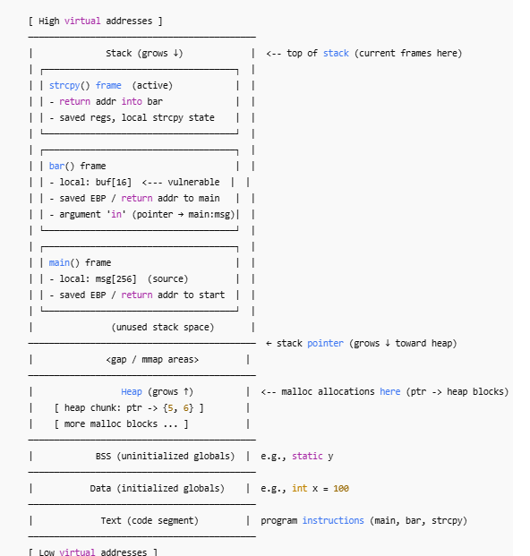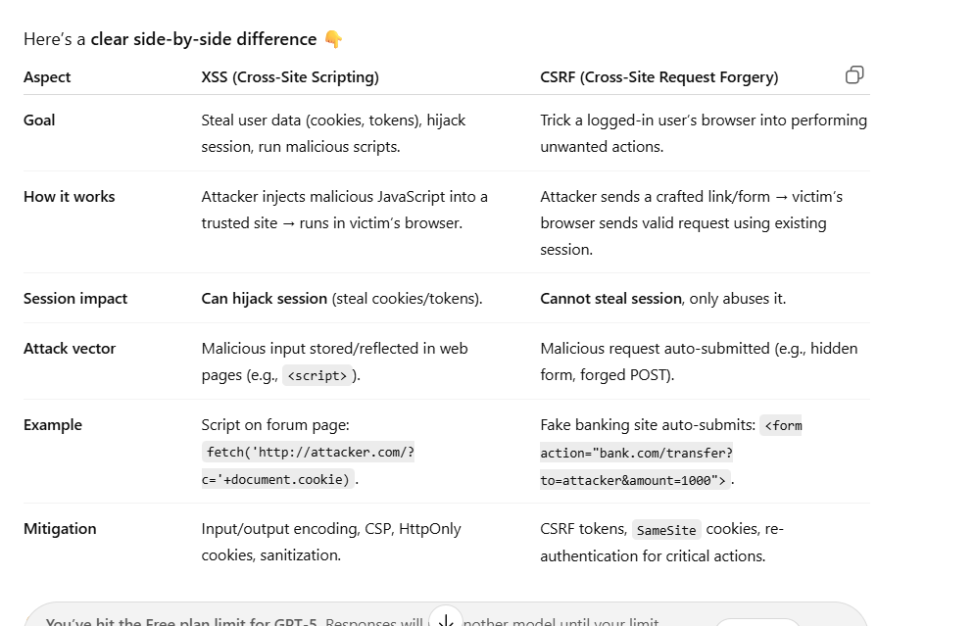

Here is a **very simple and exam‑friendly explanation** of the **three stack regions** with **examples** 👇

## 1️⃣ Parameters (Function Arguments)

**What they are:**  
Values passed **to a function** by the caller.

**Where stored:**  
On the **stack above the return address**.

**Example:**

void foo(int x, char *p) { }

foo(10, "hi");

**On stack:**

* x = 10
* p = address of "hi"

## 2️⃣ Local Variables

**What they are:**  
Variables **declared inside the function**.

**Where stored:**  
On the **stack below EBP**.

**Example:**

void foo() {

char buf[16];

int a;

}

**On stack:**

* buf[16]
* a

## 3️⃣ Special Region (Control Data)

**What it contains:**  
Data used to **control program flow**.

**Includes:**

* Return address
* Saved EBP (frame pointer)

**Example (implicit):**

void foo() {

...

}

**On stack:**

* Return address (where to go after foo)
* Saved EBP

## 🔁 Combined Simple Stack Diagram

Higher memory addresses

───────────────────────

| Parameters |

───────────────────────

| Return Address | ← special region

───────────────────────

| Saved EBP | ← special region

───────────────────────

| Local Variables |

───────────────────────

Lower memory addresses

## 🧠 One‑line exam summary

A stack frame consists of parameters (function inputs), local variables (temporary storage), and special regions (return address and saved frame pointer used for control flow).

If you want, I can also:  
✔️ Add **real C example with offsets (EBP+ / EBP−)**  
✔️ Explain **which region attackers target in buffer overflow**

Just tell me 👍

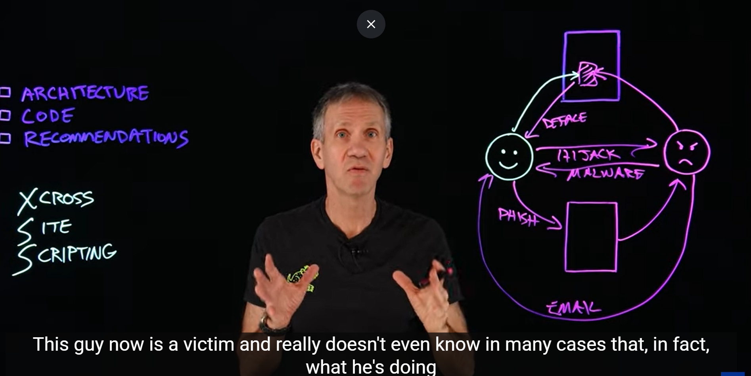

In programming, **Bytecode** is a middle-step between the code a human writes and the code a computer's hardware actually runs.

So you have this layer (Engine layer)🡪 This layer is part of browser

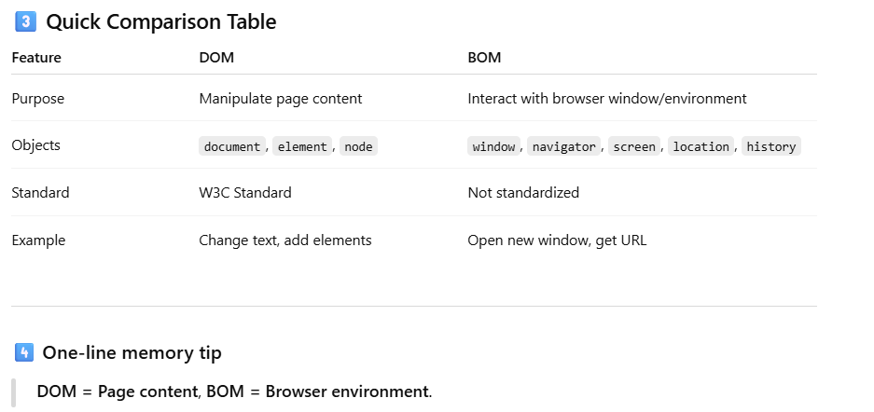

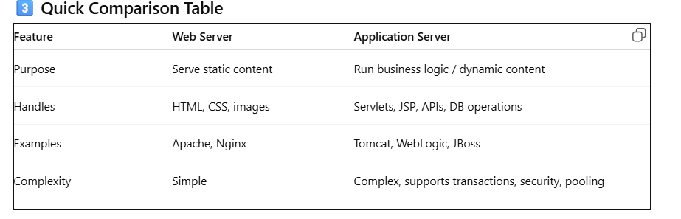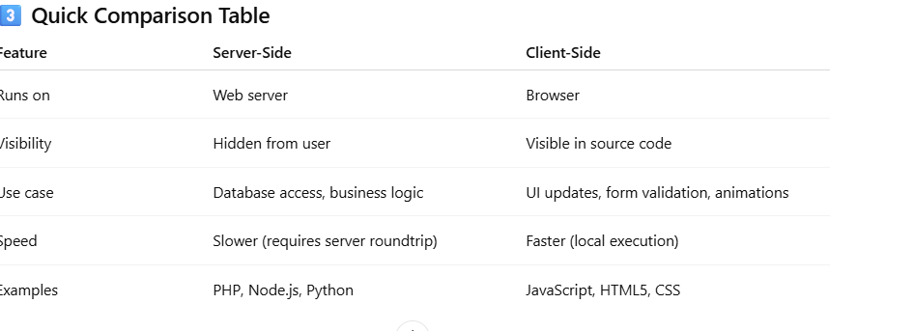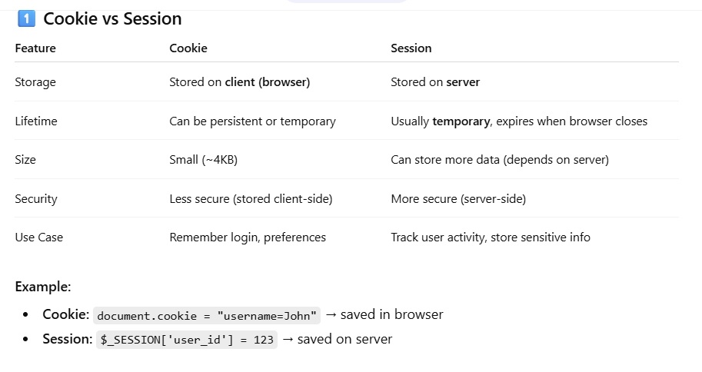

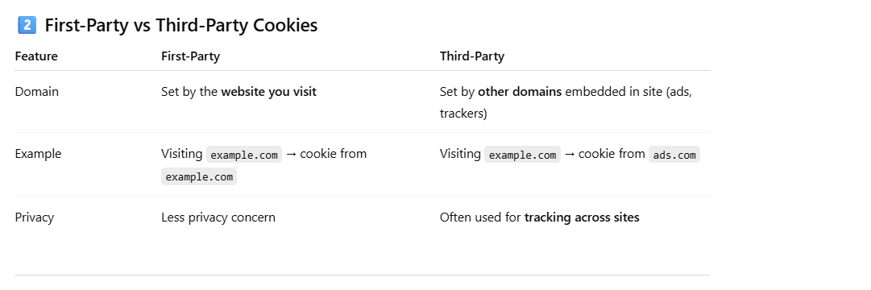Cross-Site Request Vulnerability

#

NATIONAL UNIVERSITY OF COMPUTER & EMERGING SCIENCES

As user send request to facebook server through web.com. The cookies of

facebook web page will automatically attached with the request. This is not

hijacking, but this is natural behaviour of browser. But web.com can copy

the session easily. So, this is a vulnerability of cross-site request.

Second Vulnerability:

Suppose a request is send through a webpage web.com to facebook

server. If the facebook server don’t know that where this request come

from. Then facebook server will respond to web.com page with user data.

This is also a vulnerability.

There is a type of cookies “Session cookie”. That can attach to both sites.

That may cause the problem

GET versus POST

GET has data in the URL portion

POST has data in the body portion.

All we need to know is the friend’s ID

Randomly generated session ID granted after giving the login credentials

By design browser add it for us.

Preparation of Forge GET Request

#

NATIONAL UNIVERSITY OF COMPUTER & EMERGING SCIENCES

Now attacker will prepare forge GET request in webpage with its own ID. As

victim will click on page link, forge GET request will trigger.

You have to play with their minds 🡪 once user will click on this request then

friend request will be sent.

Victim needs to have an active session with the social media site

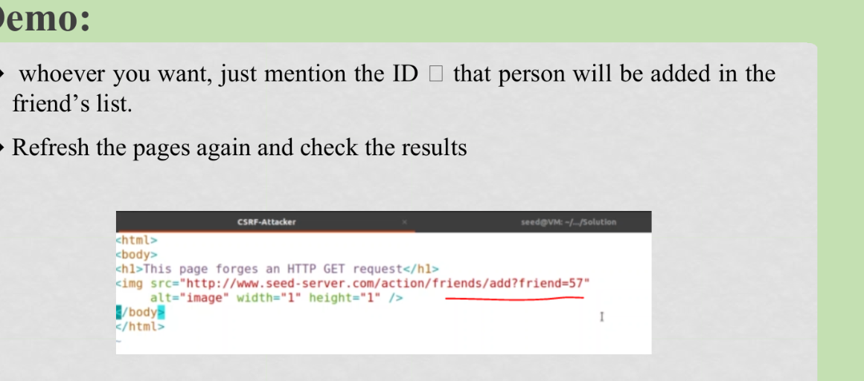

The POST request will send in forms because objective of attack is edit the

victim profile.

Preparation of Forge POST Request

Now attacker will prepare forge POST request in webpage with victim ID.

As victim will click on page link, forge POST request will trigger.

Suppose Alice and Samy(Attacker) are two user on social network like

Facebook.

Samy want to edit Alice profile without Alice permission.

The Alice user is login in her account and her session ID is created.

Samy will send url of webpage to Alice that contain forge POST request

with Alice profile ID.

As Alice click on link, the browser will trigger http POST request. The

session ID with attach automatically.

The browser knows that the http request is single-site or cross-site. But

server don’t know. This is vulnerability, because protected shield must be

deployed on server side not at browser side.

Referral Header:

The referral header tells to server that where the request come from. But

referral header carry many user information that can hit user privacy. So,

many users block referral header by proxy.

So, referral header is not reliable solution.

Secret Token

#

NATIONAL UNIVERSITY OF COMPUTER & EMERGING SCIENCES

The server attach secret token with each webpage to know about request

that it is single-site or cross-site.

The tokens are string of special characters. The property of token is hidden

so that malicious user can not steal it.

Secret Token

#

NATIONAL UNIVERSITY OF COMPUTER & EMERGING SCIENCES

The developer can generate token inside page dynamically as follows:

Http Request with Token:

Setting Cookies and its types

#

NATIONAL UNIVERSITY OF COMPUTER & EMERGING SCIENCES

The simple cookies are attached with cross-site request.

Lax cookies are sometime attached with cross-site request and sometime

not (depend upon developer).

The strict cookies only attach with same site request.

**What is xss**

The XSS attack is a form of malicious code injection in victim’s

system through website or web server.

The victim send single-site request to legal and authenticated

server. But attacker inject the code in response of server due to

server vulnerability.

As browser see code in http response, the browser immediately

execute the code.

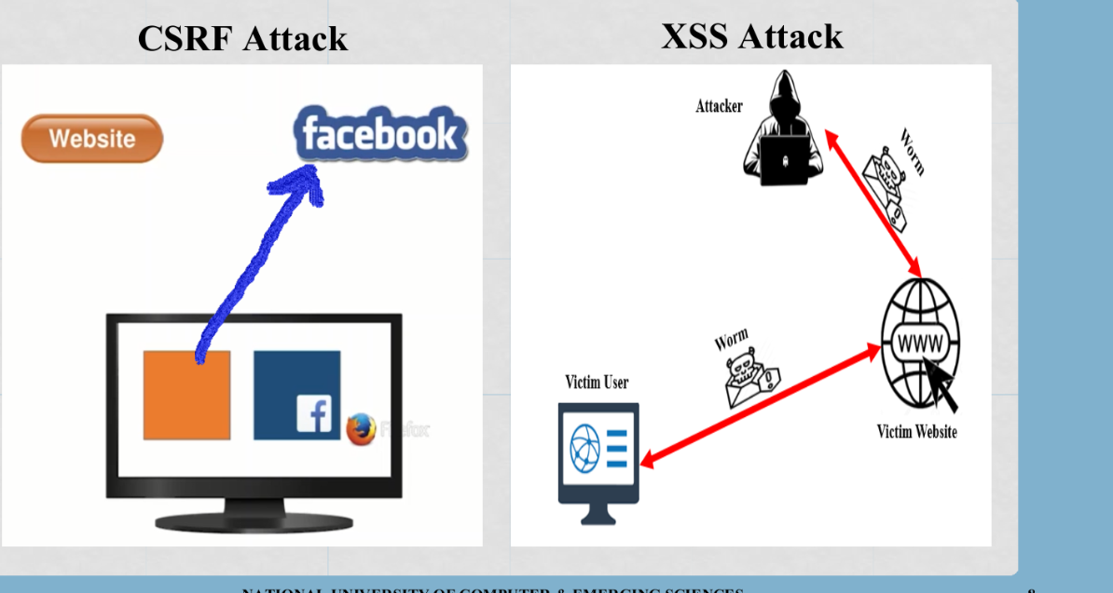

Damages

Attack server

The attacker will send http request to server on behalf of user. The

server will respond and update user profile according to attacker’s http

request.

Web Defacing

JavaScript code run inside page and code has privilege to access

element of page. The code can change, modify and delete the element.

Obama and Hillary XSS case was web defacing on client side.

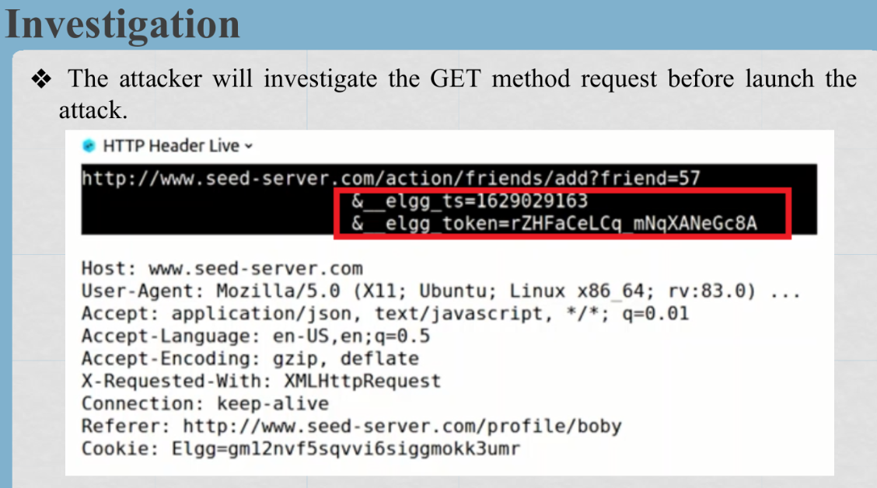

The developer use global variable for token and timestamp inside webpage.

When attacker’s malicious code is inside the webpage, then code can easily

access the global variable of token and timestamp

Elgg.security.token.__elgg_token

Construct the URL

Ajax Code

There are two ways to make identical copy of malicious code

By yourself (Self-Reproducing)

Using external help

Using External Help (Another Way)

Worm Code xssworn.js

3rd Solution: Treating data only as data

3rd solution is that use iframe as functionality of sandboxing. Actually, this solution says to

browser that treat data=[data+code] as data even it have code.

Options of Privilege Level

allow-scripts

allow-same-origin

allow-forms

allow-modals

allow-top-navigation

The CSP helps the browser to know about deputy/origin of code and data.

The CSP force the code to be labelled with respect to deputy/origin/source.

The confused deputy/origin problem

#

NATIONAL UNIVERSITY OF COMPUTER & EMERGING SCIENCES

There are two ways to include javascript code inside HTML; I) Inline

approach II) Linked Approach.

The source of linked approach must be labelled, because code may be

coming from some other resources.

One source is labelled, Then CSP privilege to code.

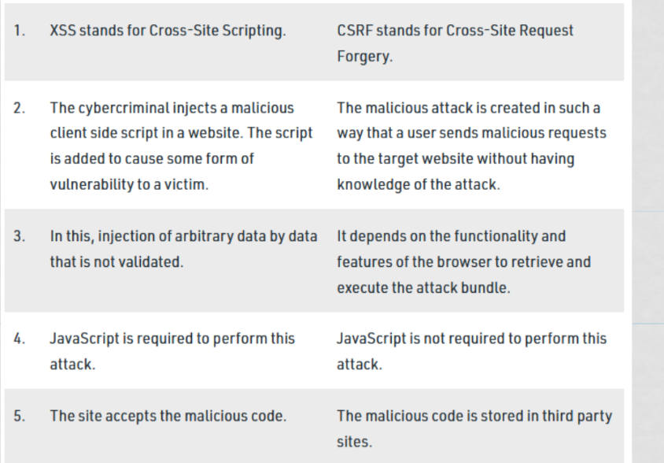

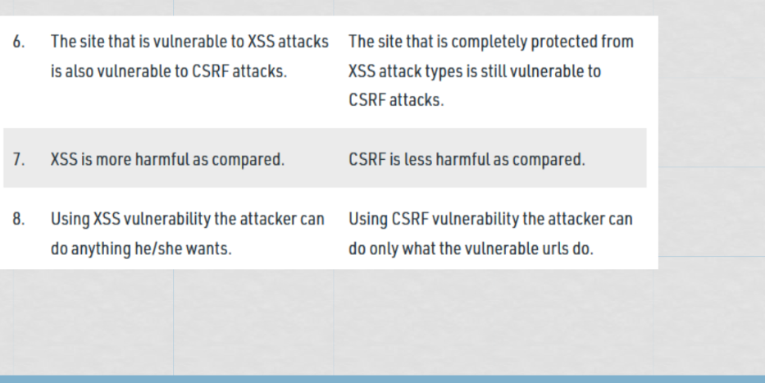

Below is a **clean, easy, exam-oriented explanation** that connects **inline vs linked JavaScript, CSP, confused deputy problem**, and **local vs global variables (tokens/timestamps)**.

## 1️⃣ Including JavaScript in HTML

### I) Inline JavaScript

<button onclick="alert('Hi')">Click</button>

<script>

alert("Hello");

</script>

* Code is **inside HTML**
* Hard to control and audit
* **Dangerous** (XSS risk)

### II) Linked JavaScript

<script src="app.js"></script>

* Code is in a **separate file**
* Source is **clearly labelled**
* Easier to trust, manage, and restrict

## 2️⃣ Why source must be labelled (important)

In the **linked approach**, JavaScript may come from:

* Your own site
* CDN
* Third-party resources

So the browser must know:  
👉 **Which source is trusted and allowed to execute code**

This is where **CSP** comes in.

## 3️⃣ What is CSP (Content Security Policy)?

**Definition (easy):**

CSP is a browser security mechanism that **controls where scripts can be loaded from and executed**.

### Example CSP

Content-Security-Policy:

script-src 'self' https://trustedcdn.com

Meaning:

* Allow scripts only from:
  + Same website (self)
  + trustedcdn.com
* **Block inline scripts and unknown sources**

### Why CSP is important

* Prevents **XSS attacks**
* Stops malicious injected scripts
* Gives **privilege only to labelled sources**

➡ This is what your sentence means:

“One source is labelled, then CSP gives privilege to code”

## 4️⃣ Confused Deputy Problem (simple)

**Definition:**

A confused deputy is a trusted program that is tricked into misusing its authority on behalf of an attacker.

### Example

* Browser **trusts a script** because CSP allows it
* That script uses **user’s cookies/tokens**
* Attacker tricks the script into sending data elsewhere

➡ The script (deputy) has **more privilege** than the attacker and is **confused**.

## 5️⃣ CSP vs Confused Deputy (connection)

* CSP limits **who can run code**
* But if a trusted script:
  + Has access to **global tokens**
  + Can be influenced by attacker input

👉 CSP alone is **not enough**  
👉 You must also control **what data scripts can access**

## 6️⃣ Why tokens & timestamps should be LOCAL, not GLOBAL

### ❌ Global variables (bad)

window.authToken = "ABC123";

* Any script (even third-party) can read it
* Enables **confused deputy** attacks

### ✅ Local variables (good)

function sendRequest() {

let authToken = getToken();

}

* Limited scope
* Not accessible to other scripts
* Reduces damage even if a script is compromised

## 7️⃣ Final exam-ready summary

* **Inline JS** is risky; **linked JS** is safer
* **CSP** allows scripts only from trusted, labelled sources
* **Confused deputy** occurs when trusted code misuses its privileges
* Keeping **tokens and timestamps local** limits attacker impact and prevents misuse

### One-line exam answer

CSP restricts script execution to trusted sources, but to prevent confused deputy attacks, sensitive data like tokens should be kept local rather than global.

If you want, I can also:  
✔️ Give a **short CSP header example**  
✔️ Draw a **confused deputy diagram**  
✔️ Explain **nonce vs hash in CSP**

Just tell me 👍

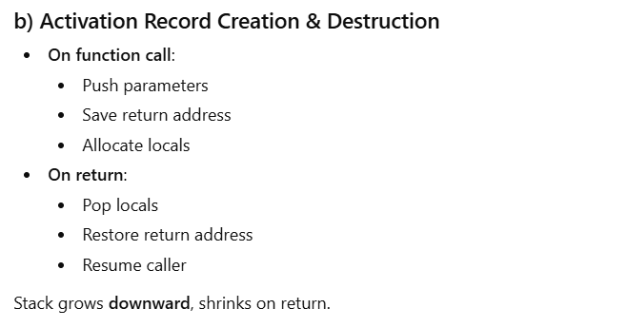Another way is that load code inside element of page as content. As web page

load in browser, the browser has API to access element by

1st Solution: Apply Filter on Data Extract

Code

2nd Solution: Turning Code into Data

3rd Solution: Treating data only as data

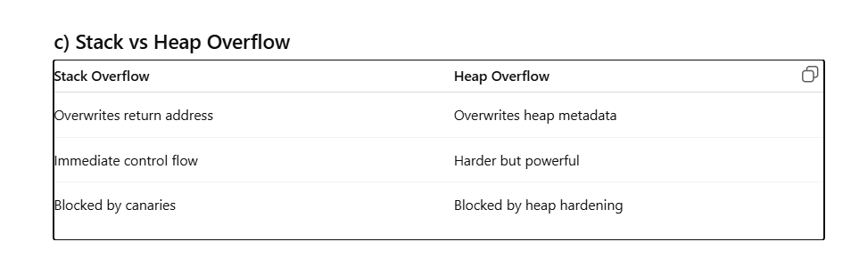 Good question — this is **basic but very important**, so I’ll explain it **slowly and in easy words**, no jargon.

## 1️⃣ “The attacker injects stored XSS into their own bio” — what does this mean?

### ****Stored XSS****

* **Stored** = saved in the database
* **XSS** = attacker puts **HTML/JavaScript code** where **normal text** should be

### ****Own bio****

* The attacker edits **their own profile bio**
* Instead of writing normal text like:
* Hello, I love photography
* The attacker writes **malicious code**:
* <script>malicious stuff</script>

➡ The website **stores this code** in the database  
➡ When **anyone views the attacker’s profile**, that code **runs in their browser**

### Why this is powerful

* Victims don’t click anything special
* Just **viewing the profile** is enough
* Code runs as **trusted website code**

## 2️⃣ What is ****Output Encoding****?

### Simple meaning:

Output encoding means **changing dangerous characters into safe text** before showing them on a webpage.

### Without output encoding ❌

Stored bio:

<script>alert(1)</script>

Browser sees:

* <script> → real HTML tag
* Code **executes**

### With output encoding ✅

Stored bio is shown as:

&lt;script&gt;alert(1)&lt;/script&gt;

Browser sees:

* Just **text**
* No execution

### Example comparison

| **Input stored** | **Output shown** | **Result** |
| --- | --- | --- |
| <b>Hello</b> | **Hello** | HTML executed |
| &lt;b&gt;Hello&lt;/b&gt; | <b>Hello</b> | Safe text |

## 3️⃣ Why lack of output encoding causes XSS

* Browser **cannot tell** if content is:
  + User text
  + Developer code
* If not encoded:
  + Browser **executes everything**
* Attacker abuses this trust

## 4️⃣ Short exam-style definition

### Stored XSS:

Stored XSS occurs when malicious scripts are saved in the server and executed whenever a victim views the affected page.

### Output Encoding:

Output encoding converts special characters into safe representations so user input is displayed as text rather than executed as code.

## 5️⃣ One-line memory trick

* **Input validation** = what you allow in
* **Output encoding** = how you show it

➡ **Always encode on output**

If you want, I can:  
✔️ Draw a **simple bio → DB → browser diagram**  
✔️ Explain **input validation vs output encoding**  
✔️ Give **1-line viva answers**

Just tell me 👍

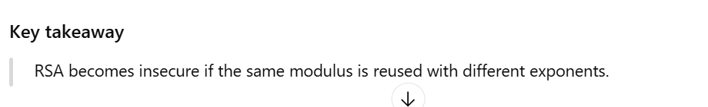

Cookies store **small pieces of client-side data** sent by the server and automatically attached to future HTTP requests.

Sessions store **server-side data** associated with a user and indexed using a session ID. 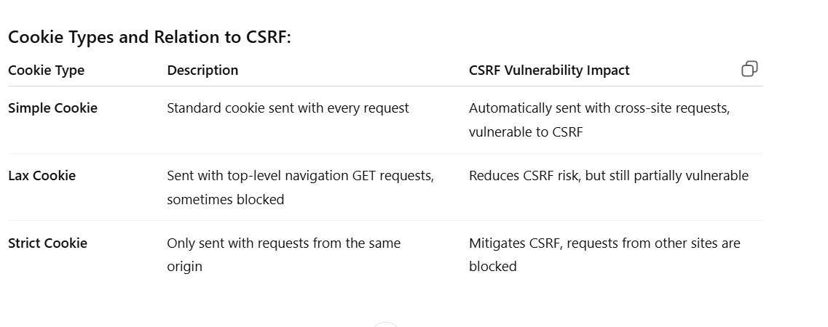

## ****Countermeasures (Very Important for Exams)****

### ****1. Use POST for State‑Changing Operations****

* GET must never be used for actions like delete, update, transfer, logout.
* This reduces accidental execution via links or images.

### ****2. CSRF Tokens (Primary Defense)****

* Server generates a **random, per-session or per-request token**.
* Token is embedded in forms and validated on submission.

<input type="hidden" name="csrf_token" value="RANDOM123">

* Attacker cannot guess or reuse it.

### ****3. SameSite Cookies****

* Prevent cookies from being sent in cross-site requests.

| **Setting** | **Behavior** |
| --- | --- |
| SameSite=Strict | Cookies only sent to same site (best protection) |
| SameSite=Lax | Sent on top-level navigation |
| None | Sent everywhere (dangerous without HTTPS) |

### ****4. Origin & Referer Header Validation****

* Server checks:
  + Origin header
  + Referer header
* Rejects requests coming from untrusted domains.

### ****5. Enforce HTTP Method Checks****

* Server should explicitly allow:

POST /transfer → allowed

GET /transfer → rejected

* Prevents misuse of GET endpoints.

### ****6. Input Validation & Authorization Checks****

* Never trust request parameters (GET or POST).
* Always verify:
  + User identity
  + Permission to perform action
  + Ownership of resources

**Xss**

**Solutions:**

1. **Filter Input/Output:** Apply strict sanitation, e.g., remove <script> tags or JavaScript event handlers.
2. **Encode Data:** Convert user input into safe characters so it’s treated as data, not executable code.
3. **Sandboxing (iframe):** Isolate untrusted code in a restricted environment.
4. **Content Security Policy (CSP):**
   * Labels the origin of code and data.
   * Blocks inline scripts unless explicitly allowed.
   * Helps prevent execution of injected scripts and confused-deputy attacks.
5. **Privilege Options in CSP:**
   * allow-scripts, allow-same-origin, allow-forms, allow-modals, allow-top-navigation.

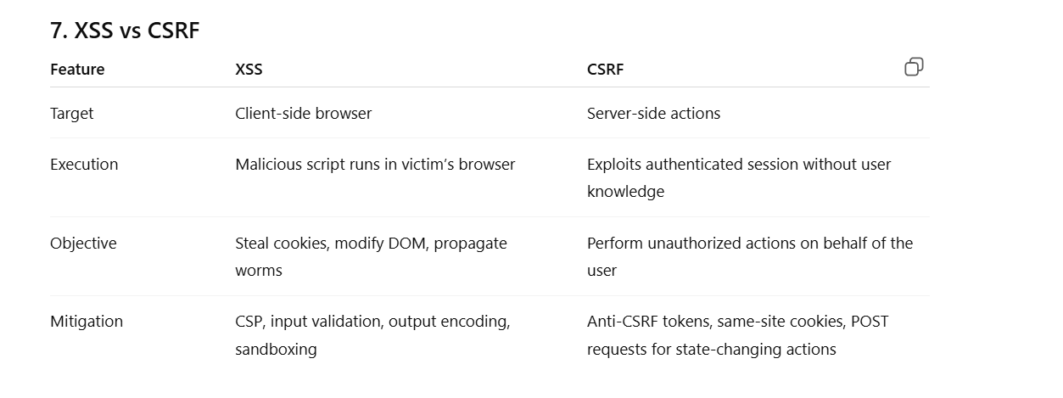

## 1️⃣ RSA (for ****confidentiality****)

* **Goal:** Keep message secret.
* **How it works:**

| **Action** | **Key used** |
| --- | --- |
| Encrypt | Receiver’s **public key** |
| Decrypt | Receiver’s **private key** |

* Anyone can encrypt a message to the receiver using their public key.
* Only the receiver can decrypt it using their private key.

✅ This ensures **confidentiality**.

## 2️⃣ PKI / Digital Signatures (for ****authentication & non-repudiation****)

* **Goal:** Prove the sender really sent the message.
* **How it works:**

| **Action** | **Key used** |
| --- | --- |
| Sign (encrypt hash of message) | Sender’s **private key** |
| Verify signature | Sender’s **public key** |

* The sender signs the message with their private key.
* Anyone can verify it with the sender’s public key.

✅ This ensures **authentication and non-repudiation**, not secrecy.

### 3️⃣ Quick way to remember

| **Purpose** | **Encrypt / Sign** | **Key used** |
| --- | --- | --- |
| Keep secret | Encrypt | Receiver public key |
| Prove sender | Sign | Sender private key |

* **Confidentiality → public key encrypt**
* **Authentication → private key sign**

### 4️⃣ Why they are opposite

* RSA can do both **depending on which key you use first**:

1. **Encrypt with receiver’s public key → secrecy**
2. **Encrypt/sign with sender’s private key → authenticity**

“Opposite” just depends on **what you are trying to achieve**.

Sure! Let’s go **step by step** with **SHL (Shift Left) and SHR (Shift Right)** using a simple example.

## ****1️⃣ Definitions****

* **SHL (Shift Left):** Moves all bits to the **left**, fills **0** on the right.
* **SHR (Shift Right):** Moves all bits to the **right**, fills **0** on the left (logical shift).

## ****2️⃣ Example****

Let’s take a 5-bit number:

[  
\text{Binary: } 11001 \quad (\text{Decimal: } 25)  
]

### ****a) SHL 1 (Shift Left by 1)****

* Move every bit **left by 1**
* Add **0 on the right**

Original: 1 1 0 0 1

Shift 1: 1 0 0 1 0 ← last bit dropped if fixed width (5 bits)

* New value (5 bits) = 10010 = **18 decimal**

✅ SHL **multiplies by 2** (approx, if no overflow)

### ****b) SHR 1 (Shift Right by 1)****

* Move every bit **right by 1**
* Add **0 on the left**

Original: 1 1 0 0 1

Shift 1: 0 1 1 0 0

* New value (5 bits) = 01100 = **12 decimal**

✅ SHR **divides by 2** (integer division, drops remainder)

### ****3️⃣ More shifts****

| **Operation** | **Binary Result** | **Decimal** |
| --- | --- | --- |
| SHL 2 | 00100 | 4 |
| SHR 2 | 00011 | 3 |

### ****4️⃣ Quick rules****

* **SHL n** → multiply by (2^n) (careful of overflow)
* **SHR n** → divide by (2^n) (drops remainder)

If you want, I can also **show SHA-style ROTR vs SHR example using same 5-bit number**, which is how SHA uses it.

Do you want me to do that?

Perfect! Let’s see **ROTR (Rotate Right) vs SHR (Shift Right)** with a simple 5-bit number.

## ****1️⃣ Definitions****

* **SHR (Shift Right)** – Moves bits **right**, fills **0s on the left**
* **ROTR (Rotate Right)** – Moves bits **right**, but bits that fall off the right **wrap around to the left**

## ****2️⃣ Example number****

Binary:

[  
11001 \quad (\text{Decimal: 25})  
]

### ****a) SHR 1 (Shift Right by 1)****

* Move all bits **right by 1**
* Fill left with 0

Original: 1 1 0 0 1

SHR 1 : 0 1 1 0 0

* Result = 01100 = **12 decimal**

✅ SHR **loses the rightmost bit**

### ****b) ROTR 1 (Rotate Right by 1)****

* Move all bits **right by 1**
* Bit that falls off **right end comes to left**

Original: 1 1 0 0 1

ROTR 1 : 1 1 1 0 0

* Step: last bit 1 moves to front → 1 1 1 0 0
* Result = 11100 = **28 decimal**

✅ ROTR **no bits are lost; they wrap around**

### ****c) Compare SHR vs ROTR****

| **Operation** | **Binary** | **Decimal** |
| --- | --- | --- |
| SHR 1 | 01100 | 12 |
| ROTR 1 | 11100 | 28 |

**Key difference:** SHR loses bits, ROTR preserves all bits by wrapping.

### ****5️⃣ Quick tip (SHA-style)****

* SHA uses **ROTR** for mixing bits in a **circular way**
* SHR is used to **shift out bits** during calculation

If you want, I can also **show ROTR 2 / SHR 2 for the same 5-bit number** so you can see patterns quickly — it’s very handy for SHA exam problems.

Do you want me to do that?

